Information Report - Revision

Week 8 assignment 6

ENG 316

Technical Communications

08/28/17

Name: Kennedy Kabaso.

Professor: Dennis McGeehan.

**How a vacuum cleaner work**

Good morning everybody. I would like to welcome you to the class of science. Today you are going to be shown how the vacuum, you use in the house works. Before the process start, every part of the vacuum is going to be labeled, some instructions how it works is going to be written and some questions will be taken from those who may have one.

In the diagram below, every important part is labeled from 1 to 8. So each part of the vacuum ‘s purpose will be explained to you so that you can understand what will be talked about.

**Names Labels**

* [Electricity](http://www.explainthatstuff.com/electricity.html) outlet 1
* Electric motor 2
* [Rubber](http://www.explainthatstuff.com/rubber.html) bel 3
* Brush and beater 4
* Fan 5
* Dirt bag 7

**How does a vacuum cleaner work?**

This diagram shows every detail of an inside of a conventional vacuum:

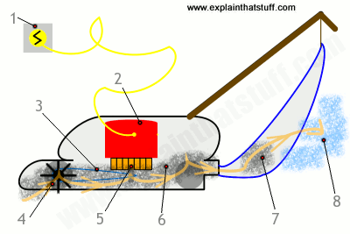

1. [Electricity](http://www.explainthatstuff.com/electricity.html) outlet is where you plug the Vacuum power cable. It supplies electric energy to the electric motor which is labeled 2, connected by a yellow cable and red in color.
2. The electric motor which is labeled 2, produces between 500–1000 watts. It uses five to ten times of energy than the old one.
3. The [Rubber](http://www.explainthatstuff.com/rubber.html) belt which is blue in color on the diagram, labeled 3, is used to turn brushes labeled 4 and beaters on the roller which is at the front of the Vacuum.
4. The brush and beater labeled 4, pick up dirt from the carpet or rug during vacuuming
5. The Fan labeled 5, located under the electric motor is used to suck air and loosened dirt in through the front of the vacuum. It is also used to keep the motor from overheating.
6. Dirty air which go through to the back labeled 6, of the vacuum from the front labeled 4, helps as well to keep the motor from overheating.
7. Dirt which go through the vacuum is trapped by the dirt bag labeled 7. The bag can be removed after getting filled and disposed.
8. Clean air emerges out of the back labeled 8. It is warmer than the air which enters the vacuum cleaner because it is mixed with the heat energy from the motor.

I hope everybody have understood how the vacuum works and would put this into practice without any problem.

**Bibliography**

* Woodford, Chris. (2007/2017) Vacuum cleaners, <http://www.explainthatstuff.com/vacuumcleaner.html>.
* <http://www.explainthatstuff.com/vacuumcleaner.html>
* Smith-Worthington, D., Jefferson, S. (2011). Technical writing for success (3rd ed.). Mason, OH: Cengage.